# **ER Diagram**

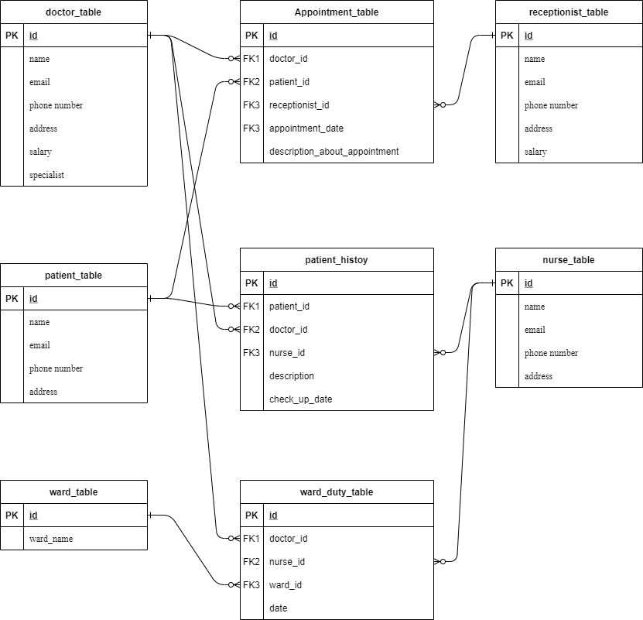

# **SQL COMMANDS**

## CREATE QUERIES:

CREATE Database hospital_database;

USE hospital_database;

**-Table structure for table `doctor_table`**

CREATE TABLE `doctor_table` (

`id` int(11) NOT NULL AUTO_INCREMENT PRIMARY KEY,

`name` varchar(255) NOT NULL,

`email` varchar(255) NOT NULL,

`phone_number` varchar(255) NOT NULL,

`address` varchar(255) NOT NULL,

`salary` float NOT NULL,

`specialist` varchar(255) NOT NULL

) ENGINE=InnoDB DEFAULT CHARSET=latin1;

**-Table structure for table `nurse_table`**

CREATE TABLE `nurse_table` (

`id` int(11) NOT NULL AUTO_INCREMENT PRIMARY KEY,

`name` varchar(255) NOT NULL,

`email` varchar(255) NOT NULL,

`phone_number` varchar(255) NOT NULL,

`address` varchar(255) NOT NULL

) ENGINE=InnoDB DEFAULT CHARSET=latin1;

**-Table structure for table `patient_table`**

CREATE TABLE `patient_table` (

`id` int(11) NOT NULL AUTO_INCREMENT PRIMARY KEY,

`name` varchar(255) NOT NULL,

`email` varchar(255) NOT NULL,

`phone_number` varchar(255) NOT NULL,

`address` varchar(255) NOT NULL

) ENGINE=InnoDB DEFAULT CHARSET=latin1;

**-Table structure for table `receptionist_table`**

CREATE TABLE `receptionist_table` (

`id` int(11) NOT NULL AUTO_INCREMENT PRIMARY KEY,

`name` varchar(255) NOT NULL,

`email` varchar(255) NOT NULL,

`phone_number` varchar(255) NOT NULL,

`address` varchar(255) NOT NULL,

`salary` float NOT NULL

) ENGINE=InnoDB DEFAULT CHARSET=latin1;

**-Table structure for table `ward_table`**

CREATE TABLE `ward_table` (

`id` int(11) NOT NULL AUTO_INCREMENT PRIMARY KEY,

`ward_name` varchar(255) NOT NULL

) ENGINE=InnoDB DEFAULT CHARSET=latin1;

**-Table structure for table `patient_history`**

CREATE TABLE `patient_history` (

`id` int(11) NOT NULL AUTO_INCREMENT PRIMARY KEY,

`patient_id` int(11) NOT NULL,

`doctor_id` int(11) NOT NULL,

`nurse_id` int(11) NOT NULL,

`description` varchar(255) NOT NULL,

`checkup_date` datetime NOT NULL,

CONSTRAINT `fk_patient` FOREIGN KEY (`patient_id`) REFERENCES `patient_table` (`id`),

CONSTRAINT `fk_doctor` FOREIGN KEY (`doctor_id`) REFERENCES `doctor_table` (`id`),

CONSTRAINT `fk_nurse` FOREIGN KEY (`nurse_id`) REFERENCES `nurse_table` (`id`)

) ENGINE=InnoDB DEFAULT CHARSET=latin1;

**-Table structure for table `ward_duty_table`**

CREATE TABLE `ward_duty_table` (

`id` int(11) NOT NULL AUTO_INCREMENT PRIMARY KEY,

`doctor_id` int(11) NOT NULL,

`nurse_id` int(11) NOT NULL,

`ward_id` int(11) NOT NULL,

`ward_duty_date` datetime NOT NULL,

CONSTRAINT `fk_doctor_duty` FOREIGN KEY (`doctor_id`) REFERENCES `doctor_table` (`id`),

CONSTRAINT `fk_nurse_duty` FOREIGN KEY (`nurse_id`) REFERENCES `nurse_table` (`id`),

CONSTRAINT `fk_ward_duty` FOREIGN KEY (`ward_id`) REFERENCES `ward_table` (`id`)

) ENGINE=InnoDB DEFAULT CHARSET=latin1;

**-Table structure for table `appointment_table`**

CREATE TABLE `appointment_table` (

`id` int(11) NOT NULL AUTO_INCREMENT PRIMARY KEY,

`doctor_id` int(11) NOT NULL,

`patient_id` int(11) NOT NULL,

`receptionist_id` int(11) NOT NULL,

`appointment_date` datetime NOT NULL,

`description_about_appointment` varchar(255) NOT NULL,

CONSTRAINT `fk_doctor_appointment` FOREIGN KEY (`doctor_id`) REFERENCES `doctor_table` (`id`),

CONSTRAINT `fk_patient_appointment` FOREIGN KEY (`patient_id`) REFERENCES `patient_table` (`id`),

CONSTRAINT `fk_receptionist_appointment` FOREIGN KEY (`receptionist_id`) REFERENCES `receptionist_table` (`id`)

) ENGINE=InnoDB DEFAULT CHARSET=latin1;

## INSERT QUERIES

**-Inserting data in doctor_table:**

INSERT INTO `doctor_table` (`id`, `name`, `email`, `phone_number`, `address`, `salary`, `specialist`) VALUES

(1, 'Dr Jennifer Coller', 'Jennifer_coller@gmail.com\r\n', '1300 856 168', 'Carlton North, VIC, CARLTON NORTH, Victoria 3054', 20000, 'Cardiology'),

(2, 'Dr Han Ling\r\n', 'han_ling123@gmail.com', '03 8560 0535', 'Melbourne, East Melbourne, Camberwell, Frankston, MELBOURNE, Victoria 3000', 25000, 'Cardiology'),

(3, 'Dr Viraj Kariyawasam', 'DrVirajKariyawasam@gmail.com', '1300 874 325', 'Rouse Hill , NSW, BELLA VISTA, New South Wales 2155', 29000, 'Gastroenterology'),

(4, 'Dr Niranjan J Arachchi', 'NiranjanJArachchi@gmail.com', '0383 917 020', 'Hoppers Crossing, Victoira, Victoria 3029', 27000, 'Gastroenterology'),

(5, 'Dr Kemble Wang\r\n', 'KembleWang@gmail.com\r\n', '03 9928 6968', 'East Melbourne, Vic, Victoria 3002', 26000, 'Orthopaedics'),

(6, 'Dr Christine Cumerford', 'ChristineCumerford@gmail.com', '0492 867 653', 'Gympie , Qld, GYMPIE, Queensland 4570', 22000, 'Orthopaedics'),

(7, 'Dr Craig Rubinstein MBBS FRACS (Plas)', 'CraigRubinstein@gmail.com\r\n', '(03) 8849 1444', 'Dr Craig Rubinstein MBBS FRACS (Plas)\r\n', 40000, 'Plastic Surgery'),

(8, 'Dr Andrea Stimming\r\n', 'AndreaStimming@gmail.com\r\n', '0490846890', 'Brisbane, QLD, Queensland 4000', 31000, 'Psychiatry'),

(9, 'Dr Tony Gianduzzo', 'TonyGianduzzo@gmail.com', '07 5444 0672', '2/5 Lyrebird St Buderim, QLD, BUDERIM, Queensland 4556', 45000, 'Urology'),

(10, 'Natasha Lane - All Over Nutrition', 'NatashaLane@gmail.com', '0480 203 381', 'Williamstown, Victoria, Williamstown, Victoria 3016', 21000, 'Paediatrics and Child Health');

**-Inserting data in nurse_table:**

INSERT INTO `nurse_table` (`id`, `name`, `email`, `phone_number`, `address`) VALUES

(1, 'Mrs Bree Tebbutt\r\n', 'BreeTebbutt@gmail.com', '(03) 5156 8309', 'Central Coast , NSW, WAMBERAL, New South Wales 2260'),

(2, 'Rachelle Domansky', 'RachelleDomansky@gmail.com', '0408943211', 'Mount Pleasant, WA, Perth, Western Australia 6153'),

(3, 'Judith Minster', 'JudithMinster@gmail.com', '+61417321684', 'East Melbourne, Victoria, Victoria 3002'),

(4, 'Dr Carl Zabel', 'CarlZabel@gmail.com', '(03) 93314125', 'Keilor East, VIC, Victoria 3033'),

(5, 'Ms Lauren Byrne', 'LaurenByrne@gmail.com', '0415 124 192', 'Vic, BAIRNSDALE, Victoria 3875');

**-Inserting data in patient_table:**

INSERT INTO `patient_table` (`id`, `name`, `email`, `phone_number`, `address`) VALUES

(1, 'Craig Wilson\r\n', 'CraigWilson@gmail.com\r\n', '0417596288', 'Mansfield, , Victoria, Victoria 3723'),

(2, 'Candy Daniels', 'CandyDaniels@gmail.com', '0419541439', 'Pakenham, Victoria, WARRAGUL, Victoria 3810'),

(3, 'Raspal Khumra\r\n', 'RaspalKhumra@gmail.com\r\n', '0458492045', 'BORONIA, Victoria, MELBOURNE, Victoria 3155'),

(4, 'Ms Linda Hansen\r\n', 'lindahansen@gmail.com', '0404189376', 'Berwick, VIC, BERWICK, Victoria 3806'),

(5, 'Mrs Kirsten Chalmers\r\n', 'KirstenChalmers@gmail.com\r\n', '0425137375', 'Ringwood, Vic, RINGWOOD NORTH, Victoria 3134'),

(6, 'Kirstin Simpson', 'KirstinSimpson@gmail.com', '(03) 9084 7455', 'Ringwood, VIC, Ringwood, Victoria 3134'),

(7, 'Cristian Acciarito\r\n', 'CristianAcciarito@gmail.com\r\n', '0405123068', 'Wantirna, VIC, Victoria 3152'),

(8, 'Janice Riley', 'JaniceRiley@gmail.com', '0413200499', 'Eltham, Victoria 3095'),

(9, 'Aimee Maxwell', 'AimeeMaxwell@gmail.com', '0456 033 200', 'DONCASTER EAST, Victoria 3095'),

(10, 'Kate Down', 'KateDown@gmail.com', '03 9890 1062', 'Box Hill South, Victoria, BOX HILL SOUTH, Victoria 3128'),

(11, 'Melinda Millar', 'MelindaMillar@gmail.com', '03 9898 0222', 'Surrey Hills, Victoria, Victoria 3104');

**-Inserting data in receptionist_table:**

INSERT INTO `receptionist_table` (`id`, `name`, `email`, `phone_number`, `address`, `salary`) VALUES

(1, 'Ms Naomi Newton', 'NaomiNewton@gmail.com', '(03) 9466-1160', 'Lalor, Victoria, LALOR, Victoria 3075', 10000),

(2, 'Tim Edwards-Hart', 'TimEdwardsHart@gmail.com', '03 9005 5425', 'Kew, Victoria 3101', 11000),

(3, 'Anna Brozovic', 'AnnaBrozovic@gmail.com', '0474 249 463', 'Kew, Victoria, Kew, Victoria', 11000),

(4, 'Melanie Bertino\r\n', 'MelanieBertino@gmail.com\r\n', '0490166977', 'Hawthorn East, Victoria, HAWTHORN EAST, Victoria 3122', 11000);

**-Inserting data in ward_table:**

INSERT INTO `ward_table` (`id`, `ward_name`) VALUES

(1, 'Outpatient Department (OPD)'),

(2, 'Inpatient Service (IP)'),

(3, 'Intensive Care Wards (ICU)'),

(4, 'Intermediate Care Waards'),

(5, 'Operation Theatre Complex (OT)'),

(6, 'Radiology Department (X-ray Department)'),

(7, 'Dialysis'),

(8, 'Laboratorium (lab)'),

(9, 'Mother Child (MOTHCHILD)'),

(10, 'Administration'),

(11, 'Entrance');

**-Inserting data in appointment_table:**

INSERT INTO `appointment_table` (`id`, `doctor_id`, `patient_id`, `receptionist_id`, `appointment_date`, `description_about_appointment`) VALUES

(1, 1, 1, 4, '2021-05-01 10:21:34', 'Check up of heart and heart pump'),

(2, 2, 1, 4, '2021-05-02 10:35:42', 'Check up of heart surgery'),

(3, 3, 3, 1, '2021-05-03 12:21:08', 'Normal Checkup for the liver'),

(4, 4, 4, 3, '2021-05-04 13:15:18', 'Check for the digestion Problem'),

(5, 5, 5, 3, '2021-05-05 10:08:25', 'Check for the arm muscles and swelling of right hand '),

(6, 6, 6, 4, '2021-05-06 12:35:20', 'Normal Check up of the leg muscles and swelling of the foot '),

(7, 7, 7, 2, '2021-05-07 08:21:36', 'Surgery of lips and left hand'),

(8, 7, 8, 2, '2021-05-07 14:28:39', 'Surgery of Right Hand'),

(9, 8, 9, 2, '2021-05-08 12:23:30', 'Checking for mental level '),

(10, 8, 10, 3, '2021-05-08 11:15:24', 'Checking of depression level '),

(11, 9, 11, 1, '2021-05-09 13:39:50', 'check up for the child ');

**-Inserting data in patient_table:**

INSERT INTO `patient_history` (`id`, `patient_id`, `doctor_id`, `nurse_id`, `description`, `checkup_date`) VALUES

(1, 1, 1, 1, 'Complete Check of the heart and functionality of pumping Heart', '2021-05-01 11:00:00'),

(2, 1, 1, 1, 'Complete information of the patient reports and suggest for surgery', '2021-05-02 11:36:48'),

(3, 1, 1, 1, 'Surgery of the heart and heart pump inserted', '2021-05-03 13:42:51'),

(4, 1, 1, 1, 'Complete check of the heart ', '2021-05-04 11:39:47'),

(5, 2, 2, 2, 'Check up of heart surgery', '2021-05-02 11:00:00'),

(6, 2, 2, 2, 'Complete information of the patient reports and suggest for surgery', '2021-05-03 11:00:00'),

(7, 2, 2, 2, 'Heart surgery operation ', '2021-05-04 11:36:11'),

(8, 2, 2, 2, 'check up heart ', '2021-05-05 12:09:40'),

(9, 3, 3, 3, 'Check for the digestion Problem and liver test', '2021-05-04 13:47:22'),

(10, 3, 3, 3, 'Food poisonings and liver swelling', '2021-05-05 14:42:32'),

(11, 4, 4, 4, 'Check for the digestion Problem ', '2021-05-04 12:17:01'),

(12, 4, 4, 4, 'Complete reports of the liver and food poisoning ', '2021-05-05 11:14:05'),

(13, 5, 5, 5, 'Check for the arm muscles and swelling of right hand ', '2021-05-05 11:11:21'),

(14, 5, 5, 5, 'Operation of right hand because of damage of the muscles ', '2021-05-06 12:17:42'),

(15, 5, 5, 5, 'infection in the arm muscles due to swelling ', '2021-05-07 10:36:19'),

(16, 5, 5, 5, 'complete check of the arm and hand muscles.', '2021-05-08 12:17:32'),

(17, 5, 5, 5, 'Medical Check up the patient', '2021-05-09 11:36:19'),

(18, 5, 5, 5, 'Medical check up', '2021-05-11 15:17:32'),

(19, 6, 6, 1, 'Normal Check up of the leg muscles and swelling of the foot ', '2021-05-05 11:00:00'),

(20, 6, 6, 1, 'Complete information of the patient reports and suggest for surgery', '2021-05-06 11:36:48'),

(21, 6, 6, 1, 'Surgery of the leg and foot', '2021-05-07 13:42:51'),

(22, 6, 6, 1, 'Complete check of the leg and foot', '2021-05-08 11:39:47'),

(23, 7, 7, 2, 'Surgery of lips and left hand', '2021-05-07 14:00:00'),

(24, 7, 7, 2, 'check up of hand ligament ', '2021-05-08 11:36:48'),

(25, 7, 7, 2, 'check up the lips and hand ', '2021-05-09 13:42:51'),

(26, 7, 7, 2, 'check up the lips and hand ', '2021-05-10 11:39:47'),

(27, 8, 7, 3, 'Surgery of Right Hand', '2021-05-07 14:36:48'),

(28, 8, 7, 3, 'check of Right Hand', '2021-05-08 16:42:51'),

(29, 9, 8, 4, 'Checking for mental level  ', '2021-05-08 12:42:51'),

(30, 9, 8, 4, 'Checking for mental level  ', '2021-05-09 12:42:51'),

(31, 9, 8, 4, 'Checking for mental level  ', '2021-05-10 12:42:51'),

(32, 10, 8, 5, 'Checking of depression level ', '2021-05-08 11:15:24'),

(33, 10, 8, 5, 'Checking of depression level ', '2021-05-09 11:15:24'),

(34, 10, 8, 5, 'Checking of depression level ', '2021-05-10 01:15:24'),

(35, 11, 9, 1, 'Checking of depression level ', '2021-05-09 13:39:50'),

(36, 11, 9, 1, 'Checking of depression level ', '2021-05-10 13:39:50'),

(37, 11, 9, 1, 'Checking of depression level ', '2021-05-11 13:39:50');

**-Inserting data in ward_duty_table:**

INSERT INTO `ward_duty_table` (`id`, `doctor_id`, `nurse_id`, `ward_id`, `ward_duty_date`) VALUES

(1, 1, 1, 1, '2021-05-01 10:40:19'),

(2, 2, 2, 2, '2021-05-02 13:25:17'),

(3, 3, 3, 3, '2021-05-03 10:40:19'),

(4, 4, 4, 4, '2021-05-04 13:25:17'),

(5, 5, 5, 5, '2021-05-05 10:40:19'),

(6, 6, 1, 6, '2021-05-06 13:25:17'),

(7, 7, 2, 7, '2021-05-07 10:40:19'),

(8, 8, 3, 8, '2021-05-08 13:25:17'),

(9, 9, 4, 9, '2021-05-09 13:25:17'),

(10, 1, 5, 9, '2021-05-10 13:25:17'),

(11, 2, 4, 8, '2021-05-10 13:25:17');

## SELECT QUERIES

**1. Simple Select queries.**

**a. Show all Doctor:** (This query will show all the details of doctors in the hospital)

SELECT * FROM doctor_table ORDER BY name ASC;

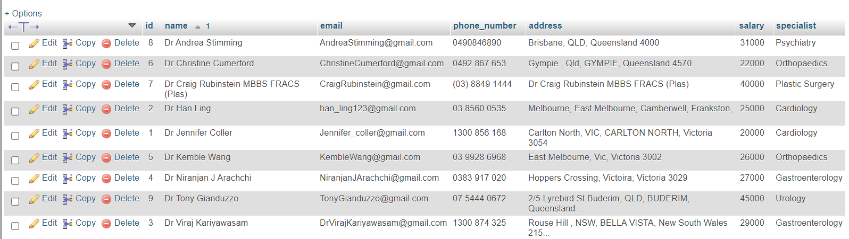

**b. Show all nurse:** (This query will show all the details of nurses in the hospital)

SELECT * FROM nurse_table ORDER BY name ASC

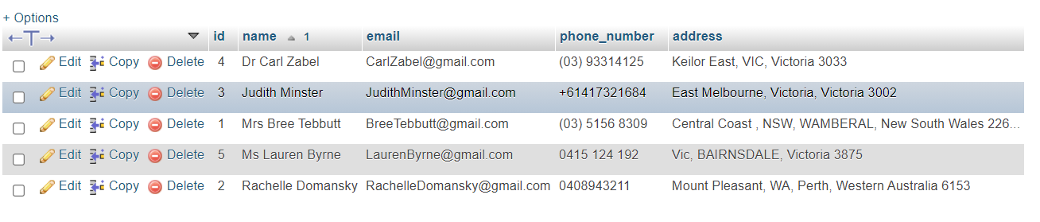

**c. Show all patients:** (This query will show all the details of patients in the hospital)

SELECT * FROM patient_table ORDER BY name ASC;

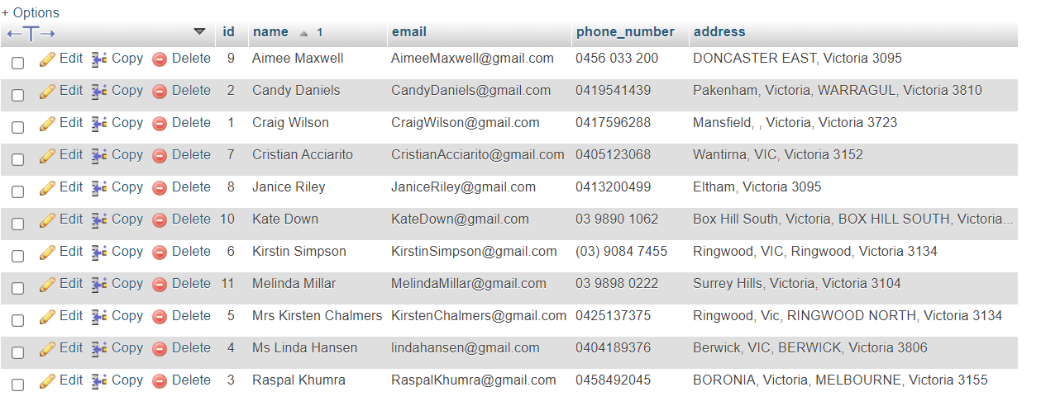

**d. Show all Receptionists:** (This query will show all the details of receptionists in the hospital)

SELECT * FROM receptionist_table ORDER BY name ASC;

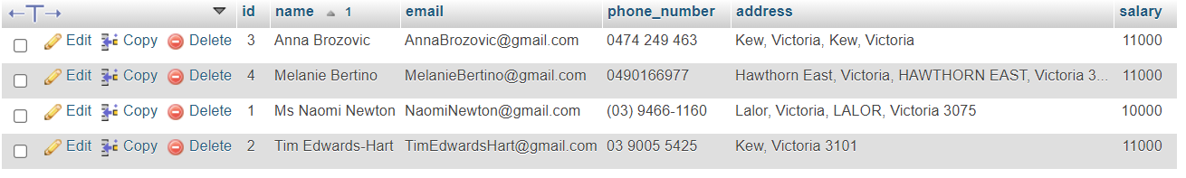

**e. Show all ward Table:** (This query will show all the details of wards in the hospital)

SELECT * FROM ward_table ORDER BY ward_name ASC;

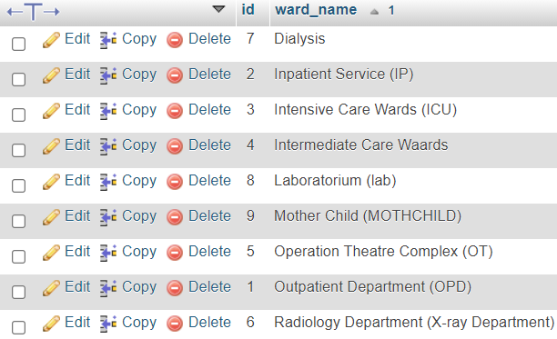

**2. Select queries with Aggregate functions**

**A. Total number of Doctor:** (This query will show total number of doctors in the hospital)

SELECT COUNT(*) as total_no_doctor FROM doctor_table;

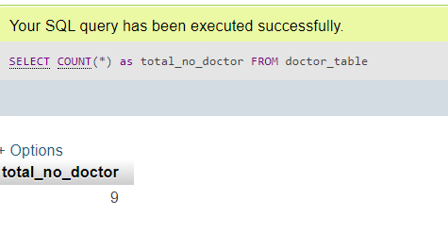

**B. Total number of nurse:** (This query will show total number of nurses in the hospital)

SELECT COUNT(*) as total_no_nurse FROM nurse_table;

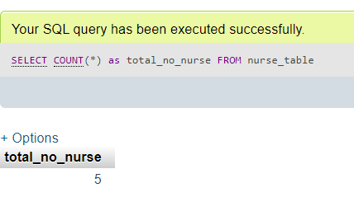

**C. Total number of patient:** (This query will show total number of patients admitted in the hospital)

SELECT COUNT(*) as total_no_patient FROM patient_table;

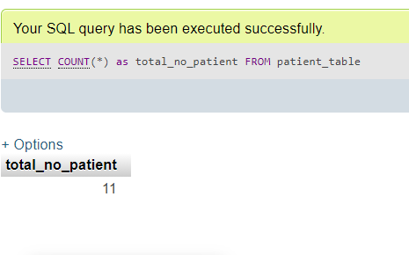

**D. Total number of Receptionist:** (This query will show total number of receptionists)

SELECT COUNT(*) as total_no_receptionist FROM receptionist_table;

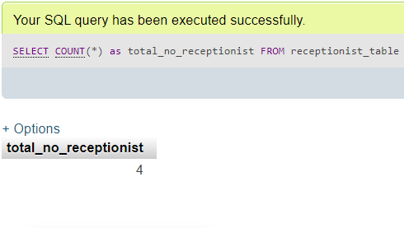

**E. Total number of ward Table:** (This query will show total number of wards in the hospital)

SELECT COUNT(*) as total_no_ward FROM ward_table;

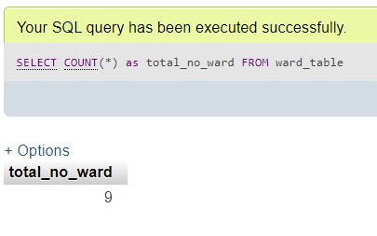

**F. Maximum Salary given to doctor:** (This query will show the maximum salary doctor is taking)

SELECT MAX(salary) FROM doctor_table;

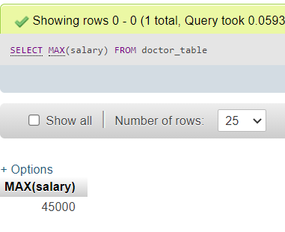

**3. Select query with where conditions**

**A. Select only those doctor which specialist of Gastroenterology:** (This query will show the list of doctors specialise in Gastroenterology)

SELECT * FROM doctor_table WHERE specialist='Gastroenterology' ORDER BY name ASC



**B. Select patient whose name is Craig Wilson and phone number is 0417596288:** (This query will filter out patients with name and phone number)

SELECT * FROM patient_table WHERE name='Craig Wilson'and phone_number='0417596288'

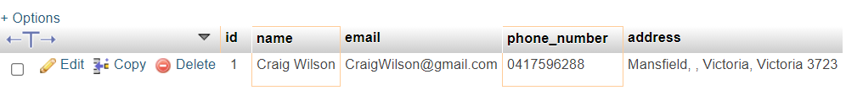

**C. Select maximum salary of doctor which specialist of Gastroenterology:** (This query will filter out doctors with max salary and with particular specialization )

SELECT MAX(salary) FROM `doctor_table` WHERE specialist='Gastroenterology'

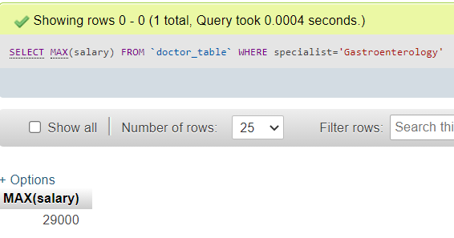

**D. Select doctor:** (This query will show all the doctors with salary more then 25000)

SELECT * FROM doctor_table WHERE salary > 25000 ORDER BY name ASC

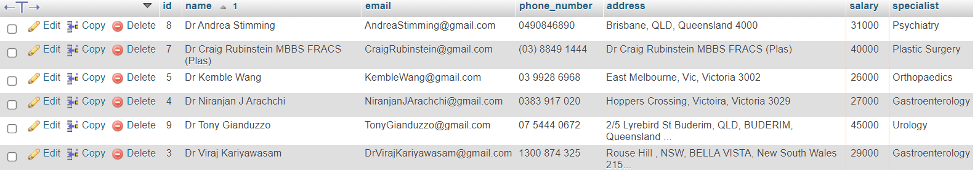

**4. join Queries**

**A. Complete Appointment Table**: (This query will show the list of doctors, nurses and receptionist with all the appointments booked)

SELECT a.*,d.name as doctor_name,p.name as patient_name,r.name as receptionist_name FROM appointment_table as a INNER JOIN doctor_table as d ON d.id=a.id INNER JOIN patient_table as p ON p.id=a.patient_id INNER JOIN receptionist_table as r ON r.id=a.receptionist_id ORDER BY a.appointment_date ASC;

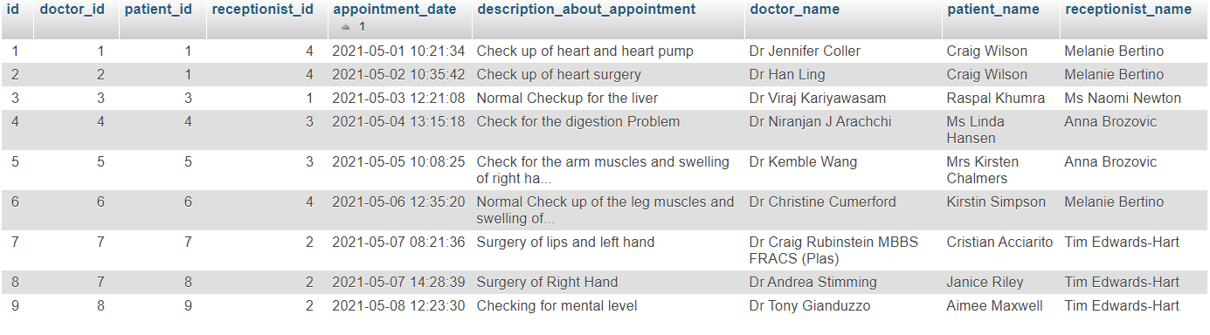

**B. Complete Patient history table:** (This query will show doctors and nurses associated with patient along with patient’s medical history)

SELECT p.name as patient_name,d.name as doctor_name,n.name as nurse_name,ph.* FROM patient_history as ph INNER JOIN patient_table as p ON p.id=ph.patient_id INNER JOIN doctor_table as d ON d.id=ph.doctor_id INNER JOIN nurse_table as n ON n.id=ph.nurse_id ORDER BY p.name ASC

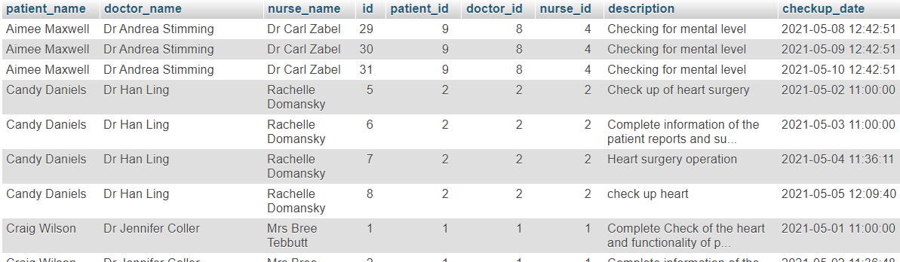

**C. Complete ward table:** (This query will show patients admitted in particular wards with doctors and nurses on duty)

SELECT d.name as doctor_name,n.name as nurse_name,w.ward_name,wdt.* FROM ward_duty_table as wdt INNER JOIN doctor_table as d ON d.id=wdt.doctor_id INNER JOIN nurse_table as n ON n.id=wdt.nurse_id INNER JOIN ward_table as w ON w.id=wdt.ward_id ORDER BY wdt.ward_duty_date ASC

